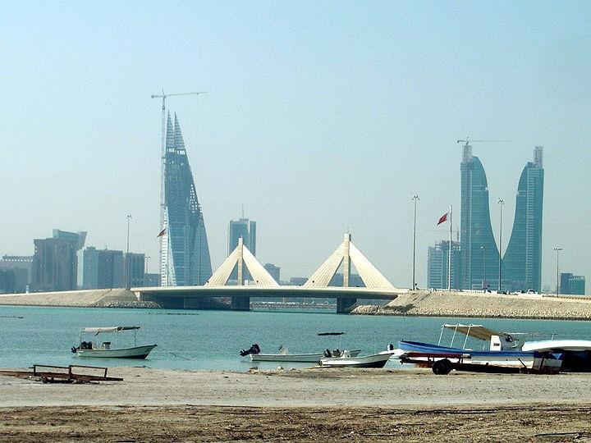
Bahrain Beaches

On any given day you feel the sand on your feet
Before you know you will taste the salt on lips
To children and young people this really a treat
But don’t stay in the sun too long this is my tip
On hot summer days, you smell the sea air.
When the tides are out, it includes the odor of fish.
Really, it’s hot and sunny so people get a tan it’s only fair.
While walking on the beach, you hear the jet skis.
Their sound is whine and whirl with human laughter.
All this happens right under wide blue clean skies.
Come to the shore and see the foolish birds play
They scream and squawk while children throw bread
Sometimes the children build castle as if they had clay.

