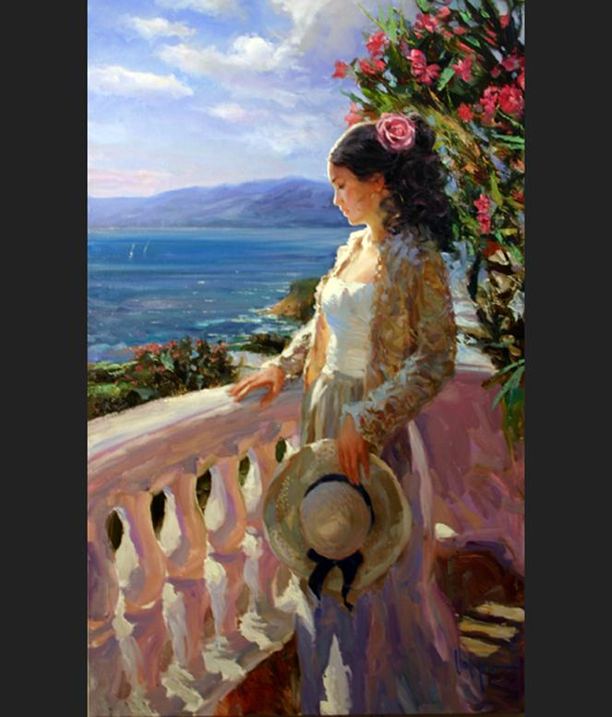
Beauty

Think black lashes that frame your dark eyes
These complement your pouty ruby red lips
They start an excited heart like sport’s car keys
Weapons like these are at your finger tips
It really is kind of sad it is just a big tease
When you go out you’re puttin’ on the ritz.

Your shapely frame within your dress
Makes a man wonder why he’s been blessed
He trembles and shakes with hot stress
Makes him happy he is not already dead
Loveliness like yours will never digress
Eyes will follow you without any dread

The world shifts on it axis with your voice
Its sound sooths the most savage of beast
Really all and all no one has even one choice
When you smile the sun begins to decrease
The population gazes and begins to rejoice
Your beauty can only continue to increase

